**Testing Documentation**

This semester for this project we used Codeception to conduct our automated tests.

(Did not finish all tests)

We used Codeception - Version 2.5.1

How to use:

1. Install Codeception: <https://codeception.com/install>
2. After Codeception is installed navigate in terminal to the GitHub repo you created on your local machine.
3. Then Navigate to the folder “Codeception Tests ”, inside you should see two folders and a file called vender(folder), tests(folder) and codeception.yml
4. In terminal you may want to set “vendor/bin/codecept” which will be the trigger for codeceptin to an alias. I used ‘alias t=”vendor/bin/codecept”’. That way you don’t have to type in “vendor/bin/codecept” everytime.
5. Now having that done you can start using the tests. In this case we created two files (in test folder and in api folder) called:

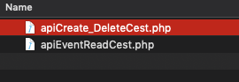

To call them you need to type in terminal:

“ t run api apiEventReadCest.php” OR “ t run api apiCreate_DeleteCest.php”

(make sure your local host is running with the SQL database… read Dev doc for more info)

these will run ALL the tests that are in that file.

1. If you need to run just one test at a time for example :

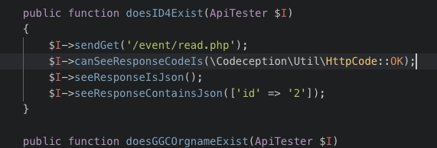

(inside apiEventReadCest.php)

The in terminal you will type in “t run api apiEventReadCest.php:doesID4Exist”

This will run only that test inside apiEventReadCest.php

1. For more help or examples watch : <https://www.youtube.com/watch?v=EE7wyjgdw78>